Christianity Beliefs Basic Revision

Christianity as a world faith  - One in three people in the world are Christians.  - Christianity was founded when Jesus died on the cross.  - His disciples spread his message with the apostle Paul  - It became the official religion of the Roman Empire. |  | Monotheistic  One God or Supreme Being  ‘Thou shall have no other gods before me’ Exodus 20:2-3
Catholic: based in Rome, led by the Pope. | Orthodox: Mainly practiced in Eastern Europe | Protestant: The Bible is the central authority.
Denomination: group | Holy: special, set apart
Omnipotent  ‘Nothing is impossible without God’. Luke 1:37 | Benevolent  ‘God loved the world that he gave his only son’ John 3.16 | Just: God does not support injustice, ill treatment, prejudice or oppression.
Omnipresence: All ways there | Omniscience: all knowing | 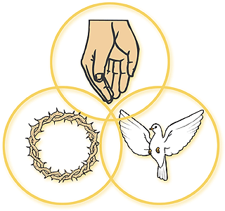
Trinity:  - There is one God  - Each person is fully God  - The persons of the Trinity are not the same. | Father ‘Our father in Heaven’  Creator, powerful, loving, all-knowing, all present.  Holy Spirit: Watches over earth to sustain life and guide.  Son: Jesus was human and God on Earth.
Genesis 1:1-3 ‘In the beginning, God created Heaven and earth’. He then made it fit for life. Humans were the last of the creation and it was ‘good’. Some Christians believe it is a literal account whereas others believe it tells a story.
John 1:1-3 ‘In the beginning was the word and the word was with God’.
Many believe the word is Jesus and the Holy Spirit was involved from the beginning.
Incarnation: God showed himself as a human and lived for 30 years, becoming flesh, taking human flesh. |  | Blasphemy: religious offence, claiming to be God
John 1:14 : ‘the Word became flesh and made his dwelling among us.’ | Mark 1:11 ‘When Jesus was baptised, a voice from Heaven said ‘You are my Son’ | Mark 15:39 ‘Surely this man was the Son of God’
Crucifixion: The execution and death of Jesus on Good Friday  - Jesus forgave the guards for his crucifixion.  - Suffered in pain  - Promised one of the other criminals, he would find paradise |  | 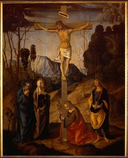
Luke 23:46 ‘Father into your hands I commit my spirit’ | Impact today: Shows that God forgives, suffering is part of life, as God experienced it, he understands suffering.
Resurrection: Jesus rising from the dead on Easter Day. Recorded in all Gospels and central to belief | Accession: 40 days after the resurrection, Jesus return to God, the father in Heaven- an eternal place of happiness and peace with God
Importance of the resurrection and ascension for Christians today
- Shows power of good over evil
- There is no need to fear death
- By forgiving others and following Christianity, you will become closer to God
- Ascension shows Jesus is with God, allowing the holy spirit to comfort and give help
- Without the resurrection, there would be no Christian faith
Apostle Creed ‘He ascended into heaven and seated in the right hand side of the Father, and he will come to judge the living and the dead: I believe in… The resurrection of the body; and everlasting life’
Judgement: A time when the world will be judged and God will reward or punish. | Parable of the sheep and Goats: Sheep go to heaven for helping others, goats end up in Hell. | John 14:6 ‘I am the way and the truth, no one comes to the Father except through me’
Hell: A place without God, ruled by Satan. Opposite of Heaven. | Purgatory: A cleansing place before Heaven. | Heaven: reward for good actions, could be a spiritual existence.
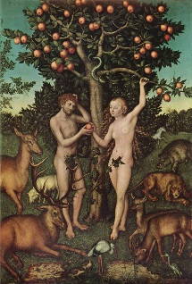 | Sin: An action that separated humans from God. Actions against God’s laws. Breaking ten commandments.  Original Sin: Eve eating the apple, all humans are thought to be born with this in them. | Salvation: Saved from sin and consequences. Granted eternal life with God.  - Good works, obeying God’s laws.  - Grace through faith in Jesus.
Romans 6:23 ‘For the wages of sin is death, but the gift of God is eternal life in Christ Jesus our Lord’ | Jesus’ death is believed to make up for the original sin, as an innocent man was sacrificed to repair the relationship with man and God. | From Jesus death mankind can receive forgiveness.
Atonement: removes sin and allows people to reconnect with God. This is only possible as Jesus atoned for man’s sins by suffering and paying the debt of man’s sins. This has given eternal life in Heaven for those who believe.

